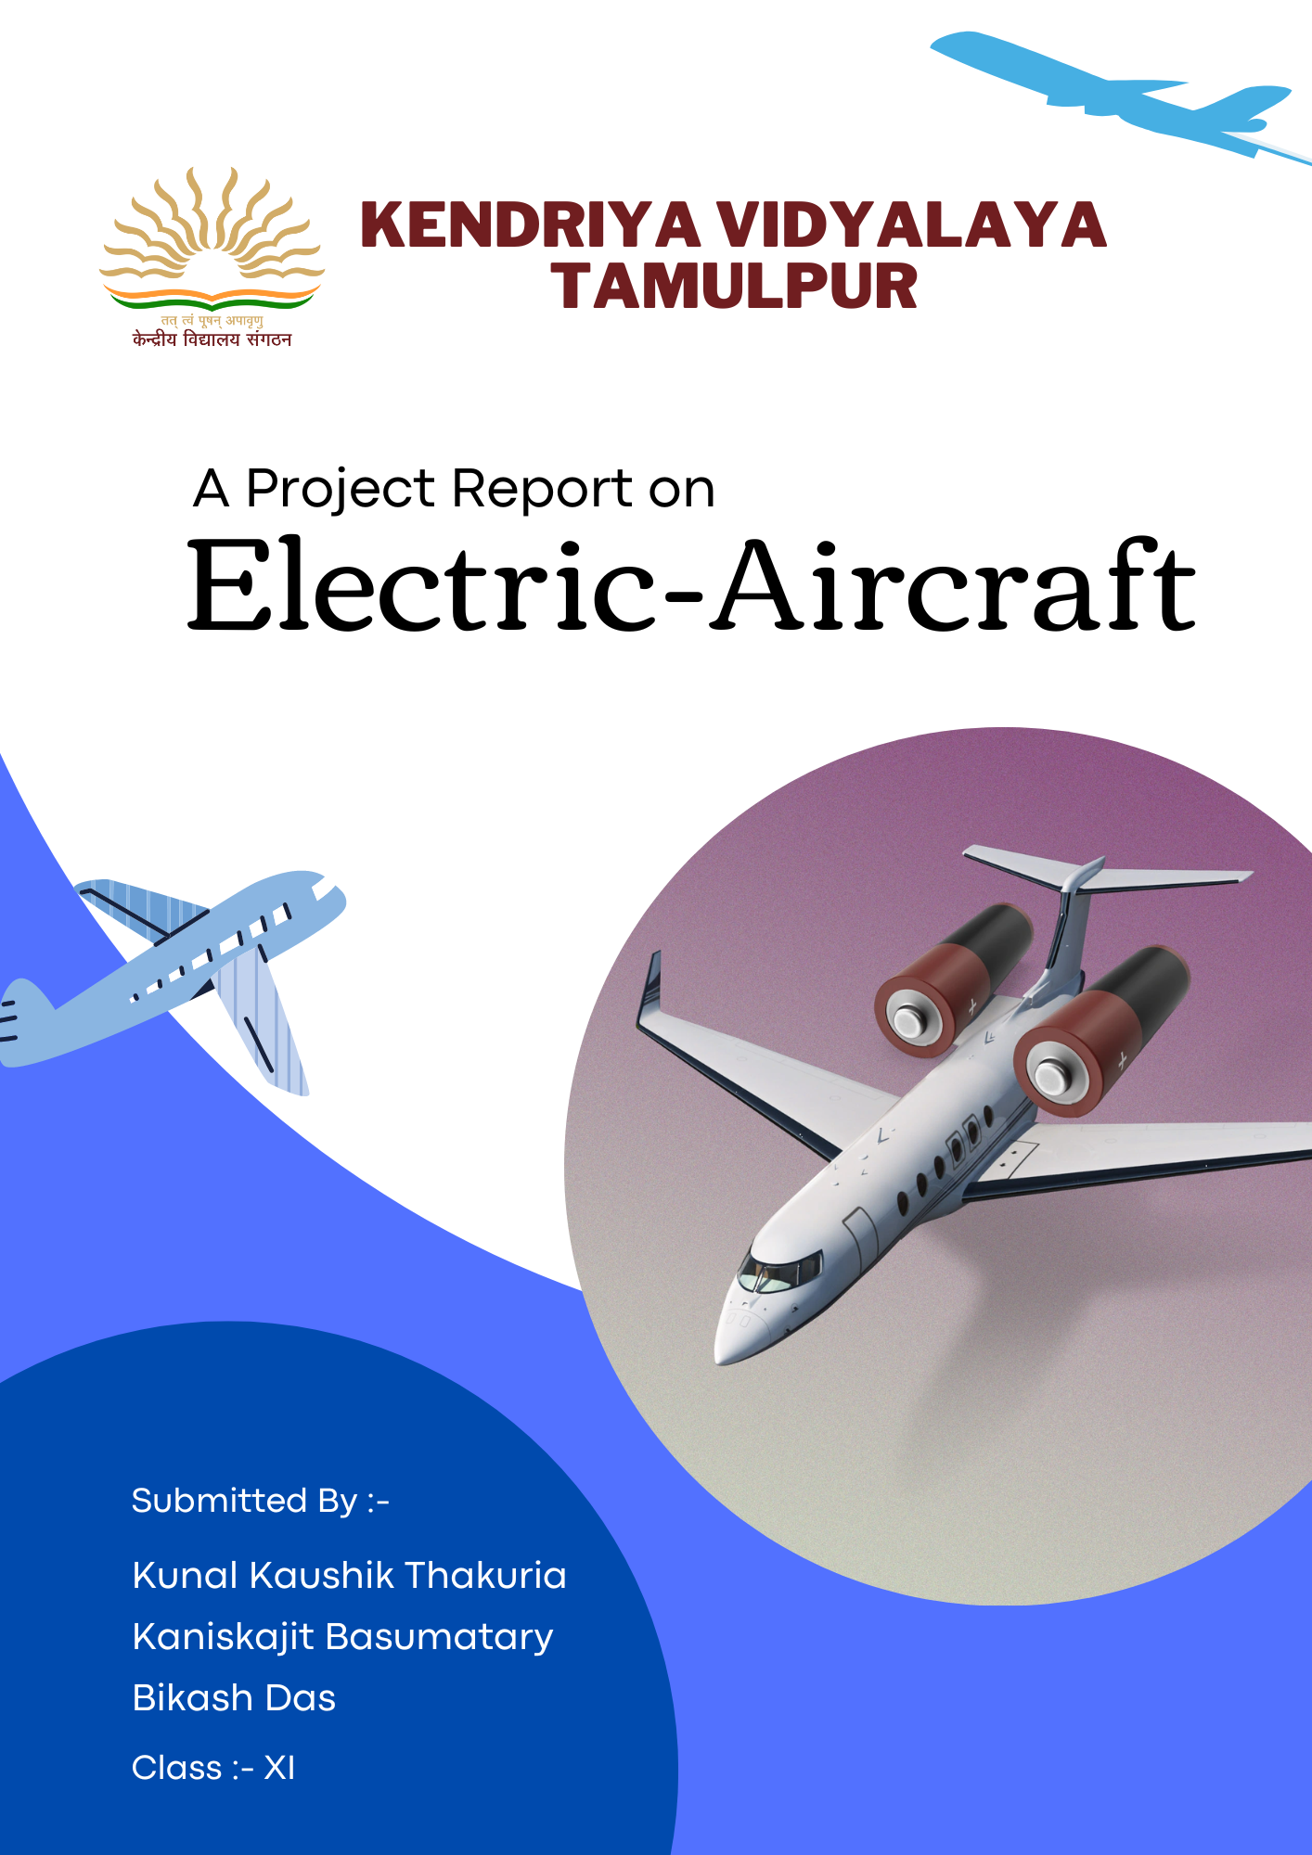



**Acknowledgement**

We, Kunal Kaushik Thakuria, Kaniskajit Basumatary and Bikash Das, would like to express our gratitude and special thanks to our respected teacher and project supervisor Mr. Sunny Yadav, whose guidance and patience allowed us to successfully complete this project report on **"Electric Aircraft"**

We want to express our profound gratitude to the school's principal in charge, Kendriya Vidyalaya Tamulpur, for his encouragement and assistance.

Besides we are indebted to our family members for their support and help. We would also like to thank our teachers, our classmates, and our close friends whose inspiration have gone a long way in giving us all the guidance, assistance and a little more better than best.

Above all, we convey our deepest thanks to God for granting us good health and for providing us the wisdom we needed to contribute to the field of work which we have been placed.



**INDEX**

* Introduction
* Electric Power System
* In all regular aircrafts
* Why do we need Electric Aircraft?
* When will regular aircraft be replaced by electric aircraft?
* Why do we not yet have electric aircrafts?
* Benefits of electric aircraft
* Hybrid electric aircraft
* Electric Motor
* Challenges
* The challenge of batteries
* Economic advantages
* Will electric aircraft cost less?
* Conclusion



***Introduction***

The conventional aircraft architectures used for civil aircraft include a mix of mechanical, hydraulic, pneumatic, and electrically powered systems. System providers spent decades developing the resulting conventional equipment.

There has been enormous growth during the last few decades. development in the direction of more electric aeroplanes.

The primary generator provides electrical power for the avionics, cabin and aircraft lighting, galleys, and other commercial loads (such as entertainment systems). Electrical power is relatively versatile and does not require a large infrastructure. The two biggest negatives are that it traditionally has a lower power density than hydraulic power and increases the risk of fire (in the case of a short circuit).

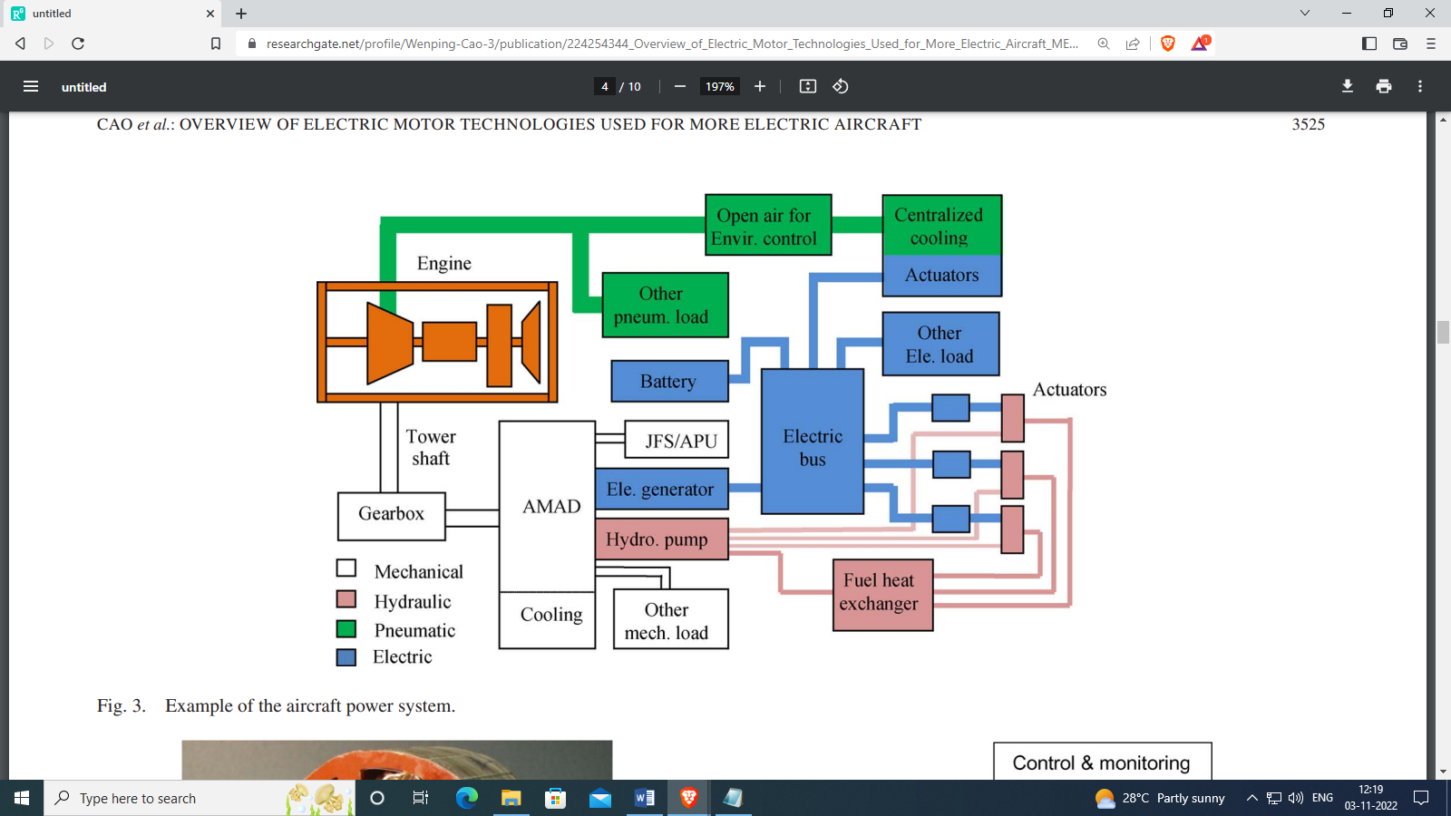

Fig. Aircraft power system.

**1**



**2**

**Electric Power System**

The common line-to-neutral AC voltage for conventional commercial transport aircraft is 115 V with a line frequency of 400 Hz. This architecture maintains the mechanical speed, and consequently the electrical frequency, on the aircraft's electric bus by connecting the generator to the main engine via a mechanical drive. This aircraft requires less electrical power generation per engine than more contemporary, all-electric models since several crucial operations, including as main engine start, environmental control systems, de-icing, and hydraulics, are not driven by electricity. Electricity is largely used in conventional constant voltage and constant frequency design to power the fans that move the air inside the aircraft. Avionics gear and hotel loads (TVs, entertainment) also utilise electricity.

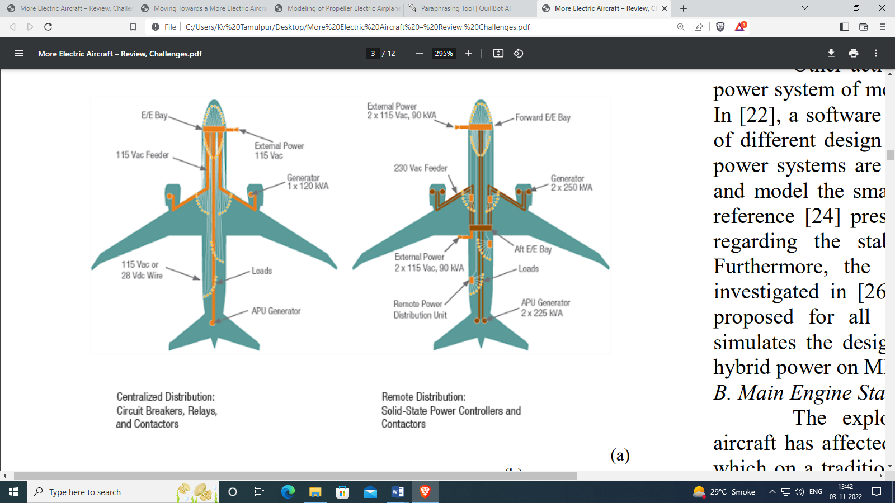



**3**

**In all regular aircrafts: -**

Each system is getting more and more complicated, and interactions between various pieces of equipment make the system as a whole less efficient. A minor pneumatic or hydraulic system leak might cause every user of that network to go offline, grounding the aircraft and causing delays to flights. In most cases, it is challenging to find the leak, and if found, it is not always simple to access. The trend is toward "all-electric" aircraft, which eliminate the requirement for on-engine hydraulic systems by utilising just electrical power off-takes from the aircraft.

Now, the attempt to transition to more electric aircraft has made significant progress over the past few decades. Electronic systems have replaced several subsystems that previously relied on hydraulic, mechanical, and pneumatic power entirely or in part. The deletion of the integrated drive generator has been one of the evolutionary modifications in more recent commercial transport aircraft (IDG). The jet engine's variable speed had been mechanically changed by the IDG to a fixed speed. This system supplied the aircraft's electric bus with electricity at a steady voltage and frequency. The removal of bleed air from environmental control systems is another illustration of how electrical systems are being used more and more. Systems for controlling the environment are employed to make passengers comfortable.



**4**

**Why do we need Electric Aircraft?**

Electric planes have certain financial benefits over conventional planes, such as the fact that electricity is significantly less expensive than fuel. Noise is one advantage. A fuel-burning engine is noisier than an electric motor, because it still needs to power a propulsor, which makes noise during take-off and ascent. Electric engines have a lot fewer moving parts than combustion engines, making them safer and easier to maintain.

**When will regular aircraft be replaced by electric aircraft?**

Because of the state of technology, electric aircraft are not being developed. Around the world, 80% of aeroplanes run on aviation kerosene, commonly known as QAV, which is a fossil fuel. We need to be more advanced in the electrical industry if we want to replace conventional aeroplanes with electric ones. Compared to conventional aircraft, electrical aircraft should be lower in weight and use less electricity.

Since conventional aeroplanes consume a lot of fossil fuel today, the world needs to move quickly toward renewable energy sources.



**5**

**Why do we not yet have electric aircrafts?**

One of history's most significant technological advancements was the development of the aircrafts. And it has operated in essentially the same manner for the previous century. However, anything might alter. A revolution in transportation is being sparked by the introduction of lithium ion batteries and electric propulsion technology. Everything is switching to electric power, including vehicles, trucks, and buses.

**Benefits of electric aircraft: -**

Noise is one advantage. A fuel-burning engine is noisier than an electric motor. It still needs to power a propulsor, such as a rotor, propeller, or fan, which makes noise during take-off and ascent. Additionally, electric engines have a lot fewer moving parts than combustion engines, making them safer and easier to maintain. Additionally, electric planes are more affordable than conventional planes due to electricity because, as fuel prices rise daily, the fuel costs make up the majority of the expense of traditional planes, whereas electricity is significantly less expensive than the fuel.



**6**

**Hybrid electric aircraft: -**

An aircraft having a hybrid electric powertrain is referred to as a hybrid electric aircraft. A hybrid electric power train can efficiently extend flight range compared to pure electric aircraft because lithium-ion batteries' energy density is significantly lower than that of aviation fuel. To date, many hybrid electric aircrafts have been produced and have been successful.

**Electric Motor: -**

A lot of people are now aware of efficient engine for environmental concerns. Additionally, electrical motor offer benefits for the environment and the economy in addition to the qualities stated below for electric motors.

* The torque response of electric motors is 100-500 times faster than that of engines.
* The output torque can be measured accurately from the motor current.
* Dispersed placement and independent control can be done easily, and the flexibility of the plane design and the degree of freedom of control are higher.
* Physical energy can be regenerated to electric energy.



**7**

Present airplanes are designed to give higher stability and controllability. For instance, an airplane's tail assembly are huge and its wings are swept back at a dihedral angle. However, these structures either require more strength, which adds weight to the aircraft, or they increase drag. To compensate the stability with control is one approach, but conventional airplanes only have three main control surfaces, and this is not enough to control the 6 degree of freedom the airplane has. The thrust is another factor that may be controlled, and thrust control method of engines has been researched. However, managing output torque is challenging, the thrust control system is intricate, and the response time is slow. On the other hand, electric airplanes’ thrust can be controlled easily due to the characteristics listed above. By developing high response accurate thrust control using electric motor. It is possible to produce high performance airspeed control. Additionally, completely novel control strategies that could not be used to traditional aeroplanes are feasible thanks to the harmonious control of dispersion distributed motor.

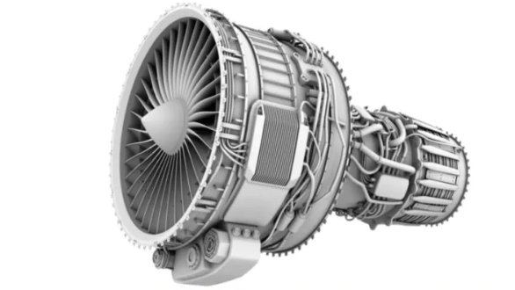



**8**

**Challenges: -**

The difficulties with energy storage in general are what aircraft must overcome today to become widely used.

It is currently feasible to have enough battery capacity for brief flights with smaller aircraft. What about motors?

Electric aircraft must meet special performance and reliability standards.

The second problem is heating. Due to electric components, electric motors are prone to overheating, and the cooling systems we would need to put in place to keep them from overheating add too much weight to the aircraft. As a result, more weight requires more power to lift, which adds to the weight problem, and we will continue in this cycle.

**The challenge of batteries.**

Energy density, power density, charging time, life, cost, and sustainability are the main issues facing battery technology. Another challenge is designing the internal battery pack topology to enable cell-by-cell monitoring. Finally, lithium ion batteries, while extremely useful, are also highly sensitive to temperature changes and naturally flammable. Due to heat, these battery packs typically deteriorate much more quickly than they would otherwise. In electrical aeroplanes, cooling systems are necessary because if a lithium-ion battery pack malfunctions, it may catch fire and cause extensive damage. However, adding cooling systems increases weight, which is problematic.



**9**

Although we may believe that batteries are the major reason electric planes are not more widely used, this is not the case.

**Economic advantages:**

Costs are a major factor in a lot of stuff. One difference is that electric planes have certain financial benefits over conventional planes.

As an example, the cost of maintenance is another one that will rise as fuel prices rise daily and aeroplane fuel requirements increase. Although we can produce as much energy as we need for electric planes using a variety of techniques, its cost is not as high as that of petroleum. Operating expenses account for the remaining savings. Fuel and engine maintenance account for over half of an airplane's hourly cost, hence electric aircraft have much lower hourly costs. How can we make a simple motor is where that technology is totally and specifically defined. Everything here functions for briefer flights where battery capacity is less of a concern. The fundamental obstacle is whether or not battery capacity can match the energy density of jet fuel.

**Will electric aircraft cost less?**

Compared to operational costs for conventional aircraft, electric aircraft have a total cost that is between 15% and 22% less.



**10**

**Conclusion**

Electrical aircraft are increasingly replacing mechanical, hydraulic, pneumatic, and electrically powered systems in commercial transport. The primary generator provides electrical power for the avionics, cabin and aircraft lighting, galleys, and other commercial loads (such as entertainment systems). Electrical power is relatively versatile and does not require a large infrastructure. The two biggest negatives are that it traditionally has a lower power density than hydraulic power and increases the risk of fire. The removal of bleed air from environmental control systems is another illustration of how electrical systems are being used more and more.

Avionics gear and hotel loads (TVs, entertainment) also utilise electricity. A leak could cause every user of that network to go offline, grounding the aircraft and causing delays. Electric planes have certain financial benefits over conventional planes, such as the fact that electricity is significantly less expensive than fuel. A fuel-burning engine is noisier than an electric motor, because it still needs to power a propulsor, which makes noise during take-off and ascent. Compared to conventional aircraft, electrical aircraft should be lower in weight and use less electricity.